


Workshop Series Forest therapy - deepening the connection with nature
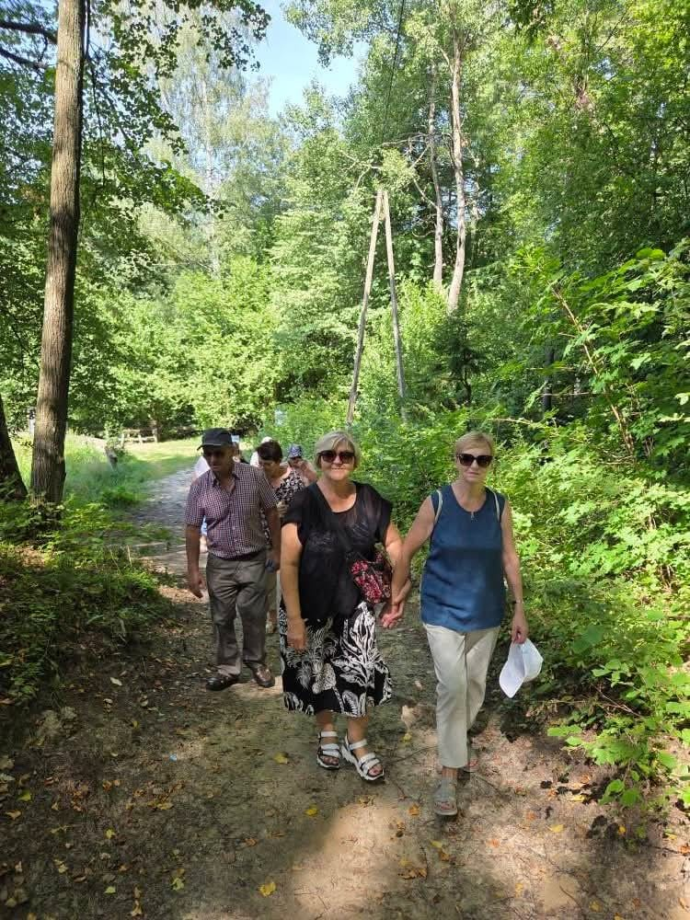
WORKSHOP PROGRAM

2025

Authors:
Non-formal learning club “WE” (Lithuania)
Stowarzyszenie Wiedza Innowacja Rozwój Poland

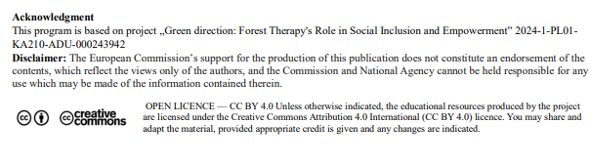

Disclaimer: The European Commission’s support for the production of this publication does not constitute an endorsement of the contents, which reflect the views only of the authors, and the Commission and National Agency cannot be held responsible for any use which may be made of the information contained therein.

‘Forest therapy - deepening the connection with nature’
For whom: adult educators, trainers, animators, people working with groups
Duration: 1 day (6-7 hours)
Place: forest, landscape park, botanical garden or other natural setting
Workshop series: ‘Forest therapy - discover a connection with nature’
For whom: adult educators, trainers, animators, people working with groups
Number of meetings: 5 sessions of 2.5-3 hours each
Form: field workshop in a forest or park
________________________________________
Meeting 1: Introduction to forest therapy and mindfulness in nature
Objectives: understanding the idea of forest therapy, building a relationship with the place and the group
Programme:
- Welcome, working and safety rules in the forest
- Brief introduction to the concept of Forest Therapy / Shinrin-yoku
- Integration exercise: ‘My memory of nature’
- Short reflection: ‘What do I expect from this cycle?’
- Concluding in a circle of gratitude
________________________________________
Meeting 2: Mindful Walking (Mindful Walking)
Objectives: learning to be present and rooted through movement in nature
Programme:
- Practising mindful breathing and movement
- Walking in silence: ‘Every step is an encounter with the Earth’.
- Reflection: what do I notice when I slow down?
- Working in pairs: ‘What does the forest teach me about my pace of life?’.
- Short summary and note in forest diary
Meeting 3: Sensory Exploration
Objectives: deepening contact with nature through the senses
Programme:
- Exercises:
o ‘Listening to the forest’ - attentiveness to sounds
o ‘Touch nature’ - exploring structures and textures
o ‘Smell the forest’ - conscious breathing
- Walking task: ‘5 senses in 5 minutes’.
- Small group discussion: ‘Which sense is easiest for me to open?’.
________________________________________
Meeting 4: Meditation and creativity in nature
Objectives: developing inner peace, expression and self-awareness
Programme:
- Guided meditation among the trees
- Creative activities:
o hugging trees and listening attentively to nature
o creating mandalas from elements of nature
o keeping a diary of emotions and thoughts
- Time of silence - individual reflection in a chosen place
________________________________________
Meeting 5: Community, ecology and final reflection
Objectives: deepening of ecological awareness and integration of experiences
Programme:
- Short presentation about the importance of the forest in culture and the ecosystem
- Group exercise: ‘What can I give to nature in return?’.
- Reflection circle: ‘How has my perception of nature changed?’.
- Ritual of gratitude - saying goodbye to the place and the group
- Presentation of symbolic ‘leaves of gratitude’
________________________________________
Effects of the whole cycle:
✅ Increased attentiveness and self-awareness
✅ Deepened connection with nature and oneself
✅ Development of empathy, calmness and emotional balance
✅ Increased environmental awareness and concern for the environment.

